The rise of rap music in China：

A comparative study of China and the United States

A niche culture refers to a group of people within a social class that come from the same or similar interests, hobbies, or traits and aggregate into a coterie culture. In the summer of 2017, with the popularity of the online TV show "China Has Hip Hop", rap, which emerged in the United States and became popular globally, once again attracted widespread attention. Compared with rock, folk songs, pop music, etc., the rap market in China needs to be explored. This is an important reason for the promotion of rap in the domestic entertainment industry. Similar to the tone of popular music that emphasizes Chinese elements and feelings in recent years, this rap promotion campaign also emphasizes "China" and even "Chinese". This also makes people pay more attention to the sinicization of the existing mainstream rap forces in China (including Hong Kong and Taiwan). This article hopes to compare the differences between Chinese and English rap markets and cultures through data-dimensional indicator analysis.

1. Instructions for use：

Run main.py in the directory

2）Song information and lyrics crawling：

Save in res/Chinese Rap.csv res/English Rap.csv

3）Frequency statistics of song lyrics：

Save in res/Chinese Rap-Word Frequency.csv res/English Rap-Word Frequency.csv

* Top100 word frequency word cloud map

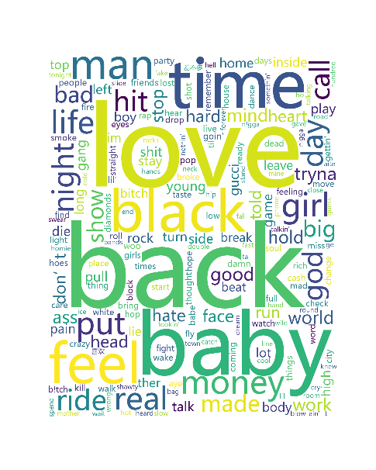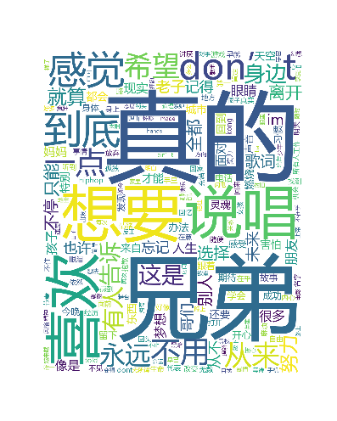

By grabbing the top100 songs, we can find that the most frequently occurring words in English rap lyrics are “love”, “back”, “baby”, “time”, and “feel”, while the most frequently occurring words in Chinese lyrics are "true" and "brother", "Want", "Like", "Rap". From these keywords, we can see that, in fact, the emotional cores of rap music at domestic and foreign are similar. On the one hand, it is the desire for emotion (brother, baby, love, like), and on the other hand, it is the pursuit of personal vision (feel, want).

Hip-hop is a relatively new phenomenon in Chinese music and has not always been accepted by the public. Most Chinese people, especially elders, see hip-hop music as glorifying drugs, sex and violence, and this has caused many parents to ban their children from listening to hip-hop. However, as participants on “Rap of China” have composed music with themes like cherishing family and friendship, recalling childhood and striving for dreams, the public has developed fresh and positive impressions of hip-hop.

* Comparison of the proportions of the top10 distribution companies in Chinese and English rap

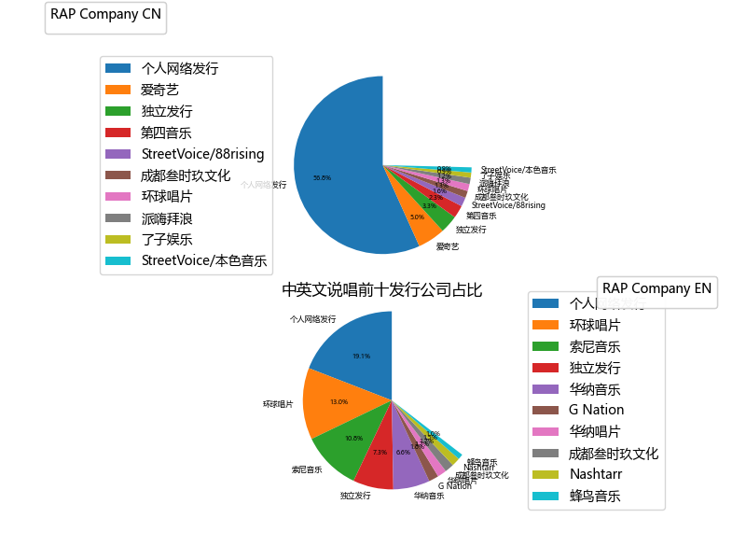

From the perspective of the top ten distribution companies of rap, whether it is domestic or foreign, personal network distribution still occupies a larger part. In addition, the proportion of independent distribution is relatively high. But the slight difference is that the scale of foreign personal network distribution is relatively small, which shows that the foreign rap song market is more mature than the domestic market, and the commercial system is more established. Domestically, in addition to iQiyi’s 5% circulation, the rest, such as Fourth Music, StreetVoice\88rising, and Chengdu Sanshijiu, all account for less than 2.3%, which is a small proportion that is relatively balanced. In foreign countries, Universal and Sony accounted for 13% and 10.8% respectively, both exceeding 10%. Then, except for Warner, which accounted for 6.6% of the circulation, all the remaining companies accounted for less than 2%. The overall market showed a form of multilateral oligarchy competition.

* Comparison of the total number of songs on the top ten singers in Chinese and English rap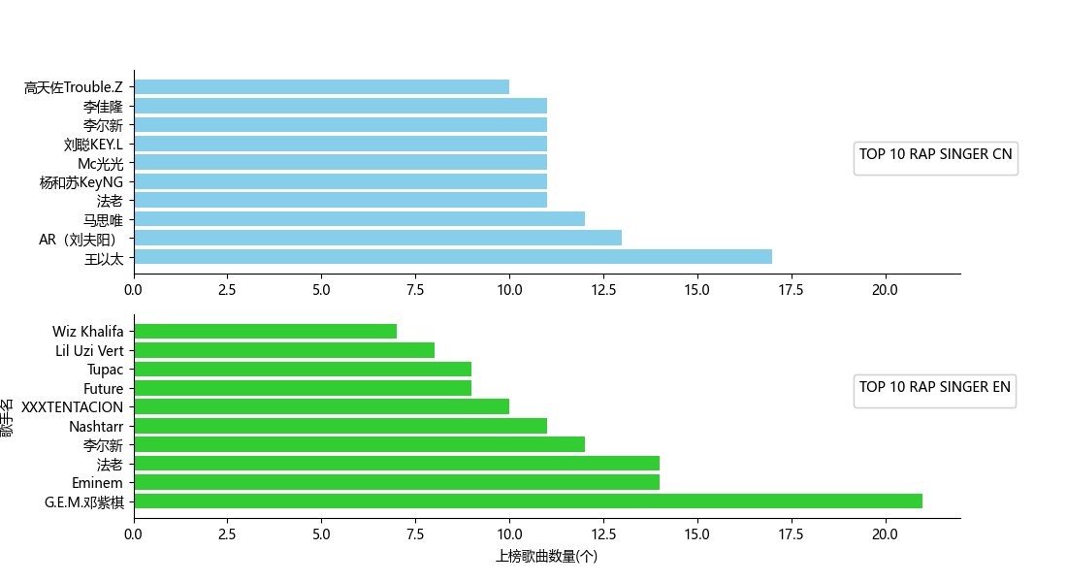

In terms of the total number of songs of the top ten Chinese and English rap singers, the distribution of Chinese rappers is relatively even. Except for Wang Yitai, who has a higher number of songs on the chart, the deviation of the other several singers’ songs from the average number is relatively low. As for the English rap songs, except for the greatest number of songs on the chart, and the rest are distributed in a ladder-like manner, which is relatively even overall.

* Chinese and English Rap NetEase score scatter plot

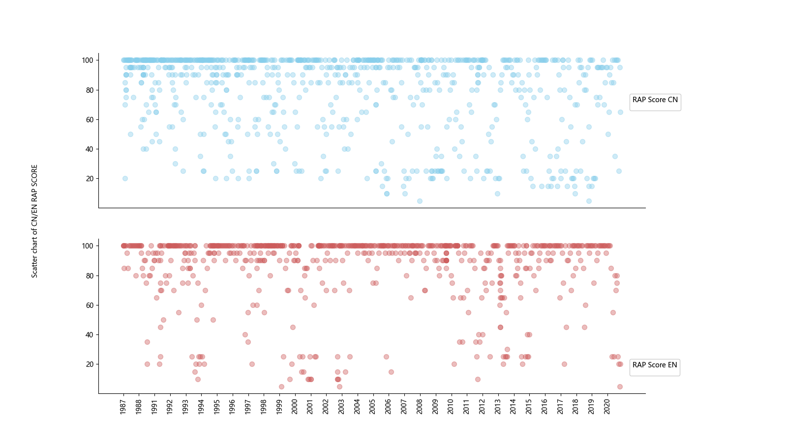

We selected one of China's most popular music software-NetEase Cloud Music and scored the Chinese and English rap songs. It can be seen that, in general, the high-segment distribution of English rap is relatively dense, while there are relatively more Chinese raps in the 0-60 range, indicating that the quality of English rap is generally high for the audience.

* Distribution of the most popular Chinese and English rap release time

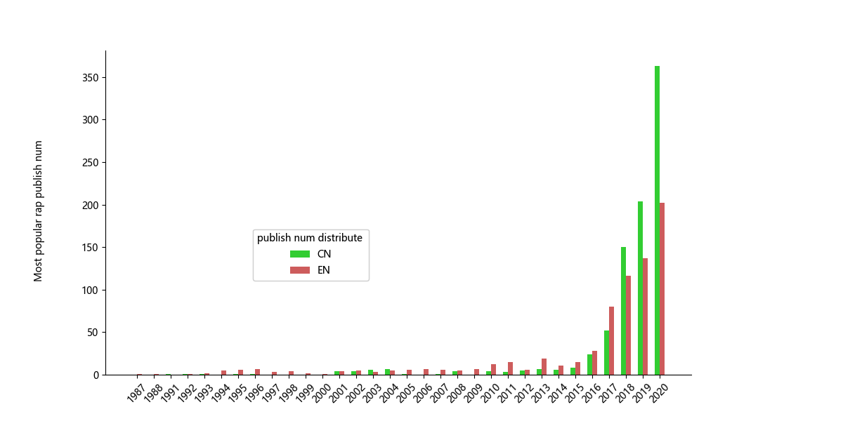

Judging from the distribution of the most popular Chinese and English rap release time, before 2017, English rap was more popular in China, while Chinese rap was less well-known in the market. However, since the end of 2017, there was a big fire show — <the hip-hop of China>, and rap has gradually entered the attention of more people. This has led to a significant increase in the release of rap songs each year since 2018, and the increase in circulation also means that the probability of liking is also increasing. Thus, since 2018, the popularity of Chinese rap has continued to rise. In recent years, the development of the singing industry has formed a closed loop. On the one hand, a large number of post-90s and post-00s groups began to fall in love with rap after the broadcast of "China Rip-Hop" in 2017 and have their own works through repeated practice and constant exchanges, and continue to choose to participate in rap programs to prove his professional ability, hoping to undertake the mission of promoting Chinese rap. In this year's "China New Rap 2020" program, many players have also returned to the stage to rectify their names.

* Comparison between Chinese and English Rap Sentiment Analysis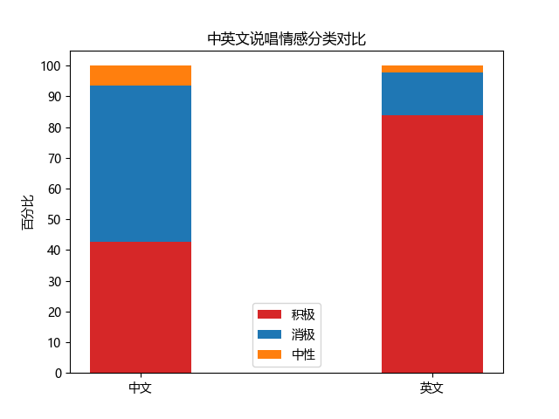

The Chinese and English rap emotion classification is mainly divided into three dimensions: positive, neutral, and negative. As can be seen from the figure, the proportion of positive and negative emotions in Chinese rap is about the same, and even the proportion of negative is slightly higher than that of positive. The positive proportion of English rap emotion classification far exceeds the other two classifications, over 80%. The main reason is that a large part of the rap is relatively vulgar, negative and does not conform to the mainstream values ​​of Chinese society so raised the positive proportion of English rap emotion classification.